**POC-5**

**ABDUR RAHMAN**

IIND YEAR CSE

**Git branching**

Step 1: Set Up Your Git Repository

1. **Create a new Git repository** (if you haven’t already):

git init <repository-name>

2.Navigate into the reposiory:

cd <repository-name>

Check status:

Step 2: Create the Main Document (Optional)

**1.Create your document** (e.g., document.txt):

touch document.txt

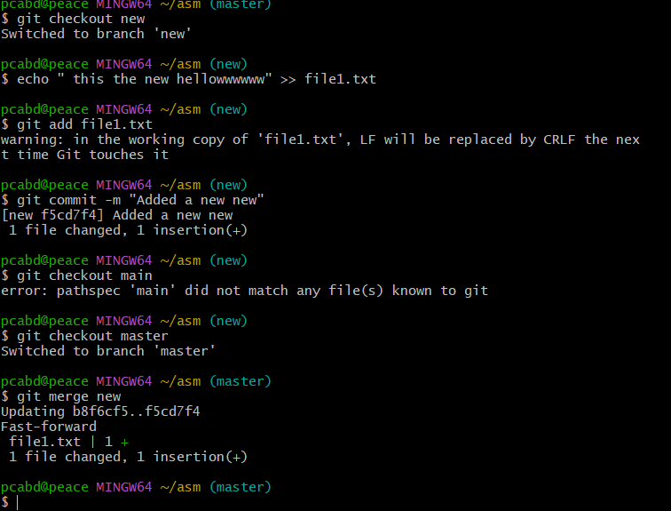

2.For add:

git add document.txt

Step 3: Create a New Branch

**1.Create a new branch** for a specific change (e.g., feature-doc)

git checkout -b feature-doc

**2.Verify the current branch**:

git branch

Step 4: Merge Changes to the Main Branch

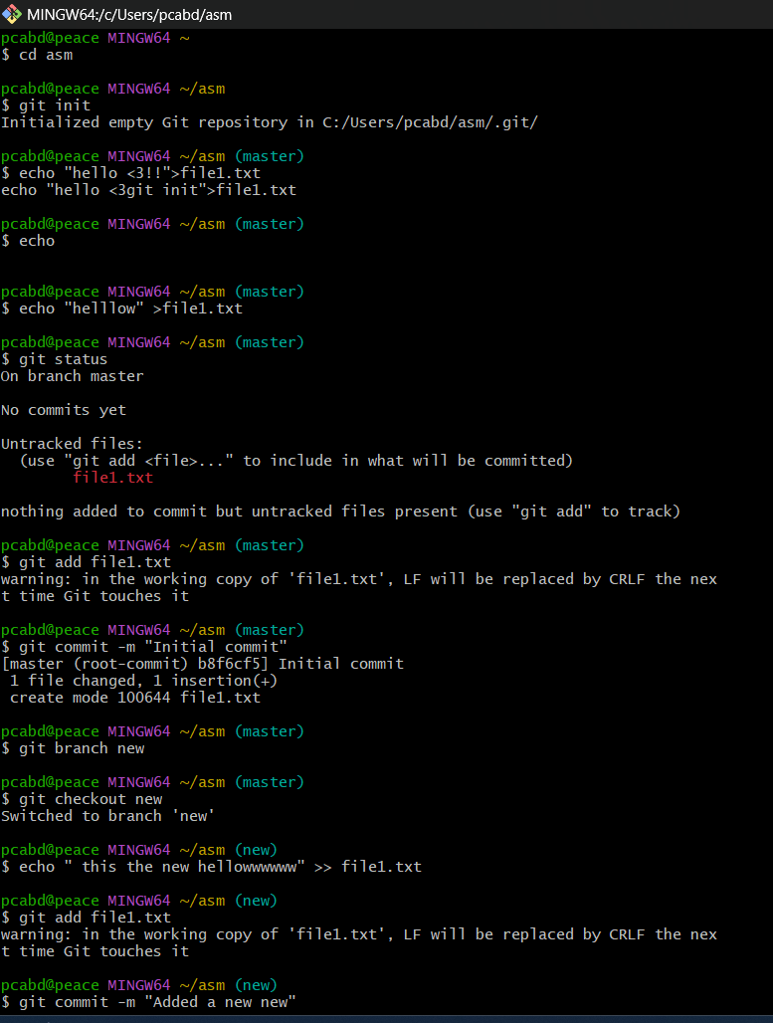

1. **Switch back to the main branch**:

git checkout main

2.**Merge the changes from feature-doc into main**:

git merge feature-doc

3.**Commit the merge** (if necessary):

git commit -m "Merged changes from feature-doc into main"

For verification:

git status

THANK YOU !3